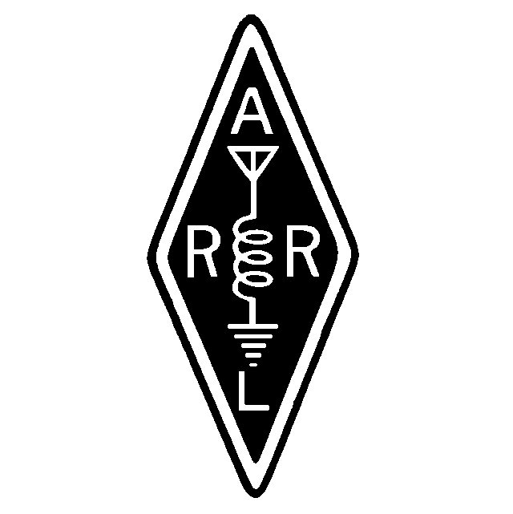
Founded January 6, 1962

May, 2000

Volume XXXVIII Issue 5

From Dave
I was unable to attend the April meeting, but the glut of work should be subsiding somewhat now and I look forward to seeing you all at the meeting this month. My thanks go to the other officers who have covered for me these last three months, and have kept me in touch with what's been happening.

These certainly are exciting times for amateur radio! As we near the predicted peak of the current sunspot cycle, the daytime bands have been wide open to many areas of the world simultaneously. In fact, twenty meters hardly seems to close. This kind of sunspot activity also brings out the DXpedition activity in droves. Last week I worked 3 new countries, at least two of which have been inactive for years.

Another reason for excitement in this hobby is the advent of the new licensing requirements. If you aren't already licensed at General class or higher, now is the time to do it. By all means, don't wait until we are at the bottom of the sunspot cycle – think of all the activity that you will miss if you do. There will also be much to learn about HF operating, but it will be a whole lot easier done at the top of the cycle.

Also, start working now on getting up an antenna for the HF bands. If you are prevented from putting up a yagi or tribander, check out the various antenna handbooks available from the ARRL and other sources. There are many wire antennas that offer gain and directivity. You can work people without gain or directivity, but you'll be able to work so many more by using antennas that have those features.

This month we'll be having elections, and a new president will be taking office. I count it a privilege to have served as president of this fine club for the last two years.

I hope to see you all on the 16th. 73, Dave Clemons K1VUT

Dave Clemons

A MARA Minute

Minutes Meeting April 2000

MEETING OPENED: 2000

Vice President Bob N1EDM presiding.

DIRECTORS PRESENT:

N1EDM, WA1GDJ

TREASURY REPORT: Mark N1ZGT

Treasurer not present. Report held until next month.

SECRETARY REPORT: Gil WA1GDJ
Gil stated that the Secretary Report was published in the Newsletter/Webpage.
Motion: To accept as published. Seconded/Approved

REPEATER TRUSTEE REPORT: Jay N1FDX, Gil WA1GDJ
Gil reported that the new Motorola repeater is now working fine and being programmed with the new controller. The antenna raising party will be on May 27, 2000 with hopes of getting the 440 and 2 mtr antennas up. Feedline has been donated by W1AV which is used 7/8 hardline.

CLUB CALLSIGN TRUSTEE: Carl N1FYZ

No new news

FOXHUNTING REPORT: Gil WA1GDJ
FoxHunters will be holding their Annual Multi FoxHunt on May 6. The hunt will start at the Highland Industrial Park off Rt. 18 at the Foxboro Co. at 1000. Hunters should meet at 0930 to register.

OLD BUSINESS:
- Dues are past due.
- Bruce K1HTN spoke on the Marathon event in Boston. There were many Amateurs from the area that were present to help out.
- Carl N1EVT also spoke on the WBZ involvement with the Marathon.

NEW BUSINESS:
- Open House at National Weather Service in Taunton, Ma. May 20 & 21, 2000.
- Harry W1DGD took charge of the Bylaw voting. He explained that the 3 changes that were recommended by the previous meeting were changed. Motion: To accept the new changes as minor changes and do not need to be published in advance of the election. Seconded/Approved. Motion: To accept the new bylaws. Seconded/Approved.
- NOMINATION OF OFFICERS. President - Bob KA1DZA, Vice President - Bob N1EDM, Secretary - Gil WA1GDJ, Treasurer - Mark N1ZGT. Nominations will be open until the election at the June meeting.
- Mark N2JWW spoke on the ADA Marathon in Marshfield on June 11. Starting time will be at 0800 until 1500. Setup crew should be there before 0800. Meeting point is the Marshfield Fairgrounds. Any radio help will be appreciated. Anyone willing to help please let Mike know in advance.
- Bill W1IFX asked the members if there would be an interest to set up a ham station at Edaville for a special event over a weekend. Members were extremely interested. Bill said that he would look into it and report back next month.
- Bob N1EDM reported on the VE session on April 15th as a huge success. He thanked all that help to make it a success. Bob passed out certificates to those that participated {Editors Note: See accompanying article further down}.
- Don, K1DC spoke briefly on his sailing trip to the Caribbean and showed some pictures he had taken.

Meeting closed at 2130.

Respectively Submitted
Gil WA1GDJ, Secretary

Remember! For every action, there is an equal and opposite government program.

Restructuring VE Session wrap-up
By Bob Mandeville, N1EDM
Whew, where do we begin? April 15 has come and gone. The Massasoit ARA/Whitman ARC VE Team (or more properly called MARA/WARC/Genesis VE Group) had their hands full. In the end, it took three days just to finish and mail in the paperwork.

The group thought they were prepared for anything – and they were. Still, with new CSCE, a new Form 605, and new regulations, there was a bit of confusion at the start, but that all settled out.

When I arrived at the E. Bridgewater Public Library, the front parking lot was already full – and this was with about a half-hour to go before the session officially began. What should we do? We set up on the tailboard of my red pickup truck and got a few of the early birds out of the way early. When the doors opened, we moved the session inside.
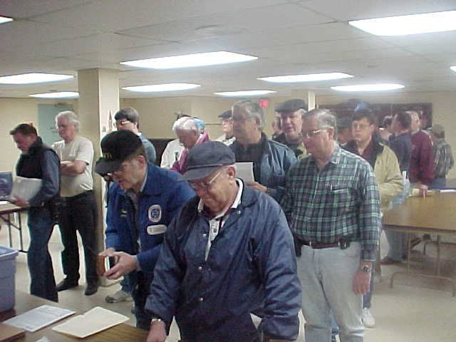

All in all, there were 50 attendees, and 52 elements given. The theory exams resulted in four upgrades to Extra! That’s not bad for three hours of work. By the time we broke down at noon, the group knew they had done a heck of a job!

I’d like to thank everyone who helped. Anchoring the VE table’s were Bob McGuire, W1TI, Samantha Harriman, N1MJP, Gene Harriman, N1EH, Bill Ward, W1ULJ, Bob McGuire, KA1DZA, and Ed Anders, W1FGD. Theory examinations were handled by the lovely and talented Evelyn Foley, K1EF, Don Tanguay, NN1D and myself.

There were a lot of non-VE’s who deserve credit – they helped to make the session run more smoothly. Frank Hayes, N1OGP took photos of the session. Bruce Beaman, K1HTN, and Kathie Mandeville, N1SGT, did Talk-in. Jeff Lehman, N1ZZN, loaned the group his vintage 1978 callbook. Five hams used for proof of pre-1987 CW. And of course, MARA can not have a ham function without John Witty, N1PRK, and his coffeepot. John took Extra theory, then made coffee for the VE’s. Talk about a lifesaver… The VE Group made a donation of five Tommy Tomkins Amateur Radio books to the library for the loan of their room. Thanks, to all of you for your help.

NWS Open House
By Gil Follett, WA1GDJ
Plans are continuing for the NWS Taunton Open House. If you want to volunteer to man the Skywarn booth, contact me please.

The NWS Open House will be held on the following dates and times:
Saturday May 20th: 10 AM-5 PM.
Sunday May 21st: Noon-5 PM.

The National Weather Service in Taunton Massachusetts is located in the Miles Standish Industrial Park. The Industrial Park is located off of Exit 9 Bay Street on I-495.

Detailed directions and events for this year's NWS Open House can be found off of the NWS Taunton homepage at http://www.nws.noaa.gov/er/box/outreach/open.htm

WARC Flea Market
Sunday and Monday, May 28 and 29, is the semi-annual Whitman ARC Flea Market at Saftlers parking lot (OK, I know that in reality it’s the parking lot next door – but everyone knows it as Saftlers). If you haven’t been there (there might be one or two of you), head down and browse the tables. You never know what you will find, either on the club table or from the other vendors.

Have a cup of coffee and a donut, chew the fat with some of your fellow hams, and work the radio station that N-Eleven-Xray (aka “The Bruce”) sets up every year. And when you’re done, please tell me why his R5 antenna gets better signal reports than my R5!

ADA Tour De Cure
Mike, N2JWW
The American Diabetes Association is hosting their annual ADA Tour De Cure from the Marshfield Fairgrounds on June 11. This event raises funds for Diabetes research, Many if not all of us know at least one person stricken with this disease. To those who have done this before, the event is a lot of fun, and you walk away with a feeling of having done something important, (as well as a T-shirt and a free lunch!). Here is an event where Ham Radio is a major help to these people.

If enough people come out, I would like to see an HF station set up and maybe even a packet station. I like these events to be fun for everyone and to show the public a little bit about the hobby. This is a great way to do it! I have also ridden this tour with the 2m rig on the bike so that may trigger some interest as well.

73's De N2JWW, Mike Halifax, MA

Field Day
Bob, N1EDM
Restructuring is over! So, what’s the next big Event (crisis?) for the club? Ladies and Gentlemen, Boys and Girls, I give you Field Day! June 24 & 25! Ham Radio’s version of Christmas in June.

Our initial plans are the same as last year – three stations, and possibly VHF. Gary DeCoster, WA1CIM, has already taken care of reserving the YMCA field again for us, for that weekend. There is even some thought (not a lot, just a little bit) given to duplicating an April 2000 QST article about flying a 160M antenna from a kite. Does anyone have 300 feet of light wire and about 500 feet of 300-ohm twinlead feedline that we could use for the weekend?

Plan on being there. The club has done well in the past two years, despite having lost about 1000 points in 1999 due to a corrupted logging file. Our best year in recent times was 1998 with Dave, K1VUT, anchoring 40M. This year, there’s an idea about using an Extended Double Zepp for 40M – that’s 180 feet of wire! Now, we have to see if there is a place where we can hang it.

That’s it for now. Keep Field Day in mind. Participate! Have a Ball! Give us your ideas!
Have You Tried PSK-31 and DigiPan
The May QST (page 42) has an article called PSK31 2000. PSK-31 hit the scene in 1999 and became popular almost overnight. The mode was simple to use, required very little bandwidth, needed very little signal strength, and didn’t require much in the way of additional equipment. If you have a PC with a sound card, all you need for a minimum hookup are two audio cables to go from your rig to the sound card, Audio In and Audio Out. You can get fancier by rigging an RS-232 line for switching the transmit on and off instead of using the VOX button on your rig.

The boon and bane of PSK-31 is its bandwidth. It’s great to be able to pack so many QSO’s into such a narrow bandwidth. It’s not uncommon to see a dozen QSO’s going on simultaneously in the span of a couple of kHz. But this is also the major complaint of running PSK-31. It is the dickens to tune in, even with the precise tuning capabilities of the newer rigs.

Enter DigiPan Software. As its name implies, it gives the operator a Panoramic view of what is happening on the band. Select one of the signals that you want to monitor, click your mouse on the trace, and you’re instantly tuned. No more fussing with the tuning dial. With this software, getting ‘close’ is close enough.

PSK frequencies can be found at 3.58-3.61 MHz, 10.140, 14.070, and 28.120 MHz. Download DigiPan from http://members.home.com/hteller/digipan. You need a 486 or faster PC running WIN95 or WIN98. You can’t beat the price – it’s Freeware!

GPS Signal Improvements!
Bob Mandeville, N1EDM
Attention GPS Receiver owners! On May 2, the US Government gave us an early Christmas present– increased accuracy!

“SA”, or Selective Availability has been switched off. SA is the algorithm that intentionally degrades the accuracy of GPS unit. With SA turned on, your receiver is only accurate to 100 Meters, about the length of one football field plus an end zone or two. With SA turned off, the accuracy is improved to 20 meters, or about the size of a tennis court. That’s not too bad for a palm-sized unit receiving signals from a satellite that is never closer than 1500 miles to you.

Amateur Radio Software
Bob Mandeville, N1EDM
The CT email Reflector talked about a new freeware called BV Software. BV is used for QSL Management and QSL Label Printing for Windows 95/98/NT - developed by Bernd Koch, DF3CB. Its main use is for Contesting and DXpeditioning with high QSL counts. BV has a very flexible log search engine making it very easy to find particular QSOs and print them on labels or directly on QSL cards. Multiple QSOs with one station are printed on the same label.

We downloaded it and could not get it to run because we found that BV requires a “Boreland data engine”, i.e., something akin to Quattro-Pro or some other data management software that they manufacture. We have Microsoft Access 97. But, in the end, the exercise did lead us to some web sites with a lot of interesting ham radio software. Log on to http://www.qsl.net/df3cb/bv.html to download BV Software or log on to http://users.otenet.gr/~sv1cns/soft.htm for BV and other packages.
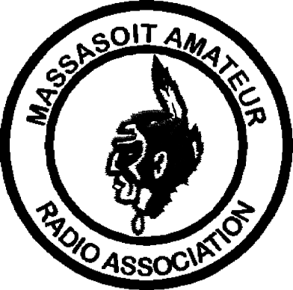MASSASOIT AMATEUR RADIO ASSOCIATION
Monthly Newsletter

Club Officers
President: Dave Clemons, K1VUT

Vice-President: Bob Mandeville, N1EDM
Treasurer: Mark Norris, N1ZGT
Secretary: Gil Follett, WA1GDJ
Repeater Trustee: Jay Zappulla, N1FDX

2M Repeater 147.180+ (Tone 67.0) 440 Repeater 444.550+ (Tone 88.5)
WHIT Node 145.090 WA1GDJ-7 (Whitman) DXCluster K1AJ, 145.690; PILGRM, 145.730
MARA Web page www.qsl.net/w1mv WARC Web page www.qsl.net/wa1npo

Monthly meetings are held the 3rd Tuesday of each month at 7:30PM at the Bridgewater Public Library in Bridgewater Center. Talk-in is on 147.180+

Our Meetings-On-The-Air are held every other Tuesday evening at 8PM on 147.180+. The net includes the Westlink News Report with the latest news about happenings in the world of Amateur Radio and topics of general interest.

The South Shore Skywarn Net is held every Saturday evening at 8PM local time on 147.180+ and is open to all hams.

From:
Massasoit Amateur Radio Association
PO Box 428
Bridgewater, MA 02324

May, 2000

To:

