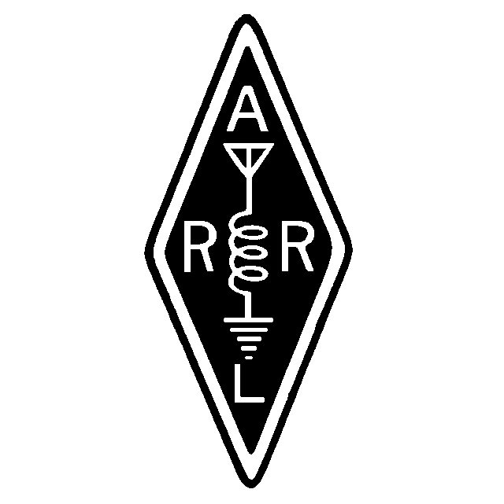

Founded January 6, 1962
June, 2000

Volume XXXVIII Issue 6

From the desktop of Bob Pratt
Good June to all. I want to start my first article by welcoming your new Treasurer, John Wittey, N1PRK, to the MARA staff. I also want to thank Vice President Bob Mandeville, N1EDM, and Secretary Gil Follett, WA1GDJ for returning for one more year. I decided to run for President because I knew that they were going to be there to either keep me out of trouble, or get into it.

Several things have been happening this month concerning MARA and I haven’t even presided over my first meeting yet! The planning for Field Day has been an ongoing event. Bob, N1EDM, started planning things before the May meeting. According to the e-mails that I have seen, those plans seem to be formulating quite nicely. If you have anything that you want to “volunteer,” including yourself, you can talk to Bob at the meeting or email him at n1edm@neaccess.net. I’m sure that he will appreciate any help or suggestions that you may have.

Skywarn was activated once again last week when several lines of powerful thunderstorms came through this area. Gil established the net on 147.225 because the .180 repeater had failed the day before. I want to thank the Whitman Amateur Radio Club for allowing Gil and Skywarn the use of their repeater. As of this writing, the .180 repeater is still down. Joe Casieri, KA1JBE is working on it in his spare time. He is trying to fix it at minimum cost to the club. Please be patient.

Most importantly, on behalf of the club, I would like to thank Dave Clemons, K1VUT, and Mark Norris, N1ZGT, for their outstanding work over the past two years. They both dug in and left the club in wonderful shape for the rest of us to take over. Thanks again for all your efforts.

In the coming months I will do my best to carry on the traditions of my predecessors by keeping the meetings as interesting as possible. I hope that I can also keep the meetings fun. We have attracted several new members by not taking ourselves too seriously and by being friendly to all of the new comers in the area. Invite your friends to the meetings for a couple of hours of comradeship and a cup of John’s famous coffee. See you at the meeting. I promise I won’t be as long winded. Bob, KA1DZA.

A MARA Minute
May, 2000

MEETING OPENED: 2000
President Dave K1VUT presiding.

DIRECTORS PRESENT:
K1VUT, WA1GDJ, N1ZGT, N1EDM

TREASURY REPORT: Mark N1ZGT
Mark read the Treasury Report
Motion: To accept as read. Seconded/Approved
SECRETARY REPORT: Gil WA1GDJ
Gil stated that the Secretary Report was published in the Newsletter/Webpage.
Motion: To accept as published. Seconded/Approved

REPEATER TRUSTEE REPORT: Jay N1FDX, Gil WA1GDJ
Gil spoke about the up coming antenna raising party at the Water Tank on May 27. Three climbers will be working on the tank top and a small contingent of helpers will be needed to assist on the ground. Starting time will be 0730 weather permitting.

Gil also stated that he and Joe W1JOE went to Dartmouth and picked up 4 lengths of 120 feet of 7/8 inch hard line for use with the 440 antenna and other antennas. Many thanks to K1EV for the donation.

Gil stated that the Motorola Amp that had been sent back to Motorola for evaluation came back as no good. Cost for a new one would be approximately $650 at a discounted price. The general consensus was to forget the amp and stay with the 30-watt brick that we are using for the time being. Maybe we can keep our eyes open for a 2-meter amp to be run out board with a little more power.

Carl stated that it would be nice to get the back-up 2-meter repeater put back in operation and used as an active back-up repeater at the VA site.

CLUB CALLSIGN TRUSTEE: Carl N1FYZ
Nothing new regarding the Club Callsign.

OLD BUSINESS:
1. Gil read an article printed in the Enterprise regarding some of our club members.

NEW BUSINESS:
- DAVE K1VUT conducted the Election of Officers for the next year. Gil brought up a point for discussion before the election was started. When Gil and Mark took office as replacement officers, the understanding was that partial year would not count as an elected term. When the next officer election came in the next May and those people were nominated that would be the beginning of their first elected term. Bylaws state that a person may hold office for two elected terms of one year each. After a little discussion on this matter it was agreed by all members present that Gil and Mark could run for another term if they wished. Dave also suggested that the bylaws be modified to include dialogue regarding taking office when someone drops their office. The opinion of the membership was that if someone has to leave office, the office has to be filled immediately. If someone volunteers to fill that capacity they should not be charged for a full year as they are serving only a partial term and not a full term, should they wish to run for office the next year. Therefore, by agreement of the members present, Gil and Mark were permitted to run another term if they wished. Mark declined the office of Treasurer. Gil stated that he would stay for another term. Nominees for office were President, Bob KA1DZA; VP Bob N1EDM; Secretary, GIL WA1GDJ; Treasurer, John, N1PRK. A formal election was held and the nominees were elected to office and will take office June 1, 2000. Congratulations to the new officers for year 2000.
- Bob N1EDM spoke on Field Day events. If anyone wants to operate at our Field Day 2000 please get in touch with Bob N1EDM. He will be formatting the events this year and will be getting out information regarding the event in the near future.
- Dave K1VUT said that he had received information on purchase of RAC Callsign CD. He said if anyone would like to put this purchase together and enough members wished to purchase one, there would be a good discount.
- Bob N1EDM said that he has room in his QSL package to send out more cards. If anyone has a small amount to send out he would be happy to send them in his package.

Meeting closed at 2130.
Respectively Submitted, Gil WA1GDJ, Secretary

Repeater Repair
On behalf of the club, we would like to publicly thank Paul Swartz, N1FWD, and Joe Casieri, KA1JBE, of Plymouth County Communications in Whitman for their work in repairing the Repeater power supply. Both have done a lot for MARA in the past on the 2M and 440 units, often giving us a ‘discount’ for work done. They have spent countless hours troubleshooting a cranky Repeater with intermittent faults, and we all know how tough those can be to fix.

MARA wants Joe and Paul to know how much we appreciate all your efforts on our behalf. If not for your efforts, we don’t know where the repeater system would be, otherwise. Mere “Thanks” cannot express our sincere gratitude for everything that you have done for the club.

Field day
Bob, N1EDM
Everybody knows when, and everybody knows where (YMCA, Rt. 106 in Bridgewater, June 24-25). Our original plans are for 3 HF stations, but a last minute glitch only has two stations available, put up by Carl and myself. The Club is in need of a 3rd station. Would you like to volunteer a station? Coordinate with myself or Carl, N1FYZ. If you don’t have all the ‘fixin’s’, we can probably help. We just need to coordinate this with the rest of the gear. Just as a suggestion, 10-Meters should be hotter than a firecracker this year!

Gil has volunteered to get a VHF station up, complete with 6M. He is also going to set up an APRS demonstration, which will get the club an extra 100 Bonus points. Gil could use a hand with his antennas, I’m sure.

John Wittey, N1PRK, has volunteered to be ‘Chef Jacques” for Field Day this year. Feel free to give John your suggestion for repast, be it Filet Mignon, Pate de Fois Gras, Pheasant Under Glass, or whatever. I’m sure that John will have an appropriate suggestion for your suggestion! Could you volunteer to bring something for the meal, such as salad, potato salad, etc? Help to take a burden off of John. Cooking at Field Day is a job in itself, and anything we can do to make life easier for the chef is always appreciated.

Setup is going to start around 8:30 – 9:00AM or thereabouts. Setup is always half the fun and we’ve had a lot of experienced hands helping us in years past. Teardown will be around 2:00PM on Sunday unless foul weather forces us to close early. We can always use some of you folks to tell us what we are doing wrong!

If nothing else, come down and operate. Field Day starts at 2:00PM on Saturday and runs for 24 hours. Scream into the mic, pound some brass, or log on one of the PC’s. but parcipiate!

As always, we ask your consideration about letting the folks operating the radios alone when they are working. If they’re sitting at the rig, it’s because they want to operate. Of course, nothing says you can’t ask them to get up and give you a try!! The more, the merrier.

QSL Via Buro

Bob, N1EDM
Here is an offer you can’t refuse. Do you have cards going to the Outgoing Bureau at the ARRL, but you don’t want to pay $6 for part of a bundle? Bring your cards to the June meeting. I will combine them with my pile and send them all in together. Present cost is $6/pound (still a bargain). But, if you have only a fraction of a pound, bring what you have and pay only the appropriate part of that $6. I will combine all the cards and send them in as one package, saving postage and costs. You only need to do three things:
- Sort cards by callsign groups
- Include proof that you are an ARRL Member (a xerox off your QST label will suffice).
- Pay your your fair share of the QSL Buro fee for the cards, to cover costs.

I will be sending my cards in just after the June meeting, so here is your chance!

And The Winner Is….
The November Sweepstakes was hot and heavy this year. Did you look at the scores? Check the June QST, page 106. Dave Clemons, K1VUT, placed 1st in New England Low Power CW, with 145,684 points to be a Plaque Winner. As a result of this score, Dave placed second in the entire Northeast Region, which includes New England, Hudson, and Atlantic Divisions, along with the Maritime and Quebec Sections. Dave made 946 QSO’s, captured all 77 sections, and ran the entire 24 hours of the contest. Congratulations, Dave!

FYI, W1MV did pretty well for herself. In a casual contesting effort, MARA got a score of 20, 414 with 173 QSO’s, 59 Sections, in only 7 hours of operation.

OK, so who wants to use W1MV for the next Sweepstakes contest? Sweepstakes is one of the first major contests of the new Contest Season. This is a good way to jump into your first contest (and perhaps get your WAS), and as a tune-up to fine-hone your operating practices for the rest of the winter contest season.

4Sale
Don Tanguay, NN1D, has a MFJ Model 564 Iambic paddle for sale. He is asking $40. Don can either hook-up with you over the air, or bring it to the club meeting.

Don, K1DC has a Yaesu FT-51R 5W 2M/70cm HT for sale: It also transmits on marine frequencies). Accessories include a FBA-14 Battery case, FNB-38 Ni-Cad pack, Periphex NiMh pack, PA-10A mobile adapter & charger, and a MH-36 speaker microphone. $250 for the package. Don will bring it to the next meeting.

Matt, N1ZZR, is selling an Icom IC-Q7A HT $ 110.00 or B.O; Yaesu FT-50RDHP $ 175.00 or B.O (Includes a spare AA battery pack and HD Spkr. Mic).

Bob, N1EDM, has a very old, but working Telex Model 18 AVT/WB-S Vertical antenna for sale. It’s good for 80-10 Meters. You supply the ground radials, per instructions. Asking $30.

Tower wrap-Up
There is still a lot of work to be done, but much of the high work at the tank has been completed. Slave-driver Gil, WA1GDJ, threatened enough people to come down and lay in new hardline and install more antennas. Another length of hardline was pulled up and fastened to the tower. There are now 4 antennas on top of the tank – the repeater, the 440 vertical, a 2M vertical to be used for packet/APRS, and Graziano’s hf vertical. There is also a 440 MHz yagi on the second mezzanine for linking. This is the only antenna not using hardline. Thanks to Joe, Marino, Chris, Jeff, Gil, Roy, Bob, etc., and all the others who showed up for their help. We hope we didn’t leave anyone out, but we’re sure we did. Forgive us for that oversight. You all did a great job.

NWS Open House
Gil, WA1GDJ, and Carl, N1FYZ, sponsored a table at the recent NWS Open House. They set up at a table in one of the event tents and gave the pitch for ham radio, Skywarn, and APRS. Both of them worked both days of the event, and Carl also worked some DX with a long-wire he put up over the trees.

Gil did an APRS demonstration on Sunday afternoon by tracking Gene Harriman, N1EH, who was APRS mobile in his car, with Samantha, N1MJP.

Balloon Launch
Hank Riley, N1LTV
The SkyQuest 3 balloon with its dual mode CW/RTTY controller made a nice leisurely 3+ hour flight over southern New England and the Atlantic Ocean Sunday afternoon under cloudy bright skies. SkyQuest 3 weight with parachute and battery was only 7.5 ounces!

A full SSB balloon ground station (for CW and OOK RTTY) was operating in one of the tents on the National Weather Service grounds at Taunton during its open house. The 4 man launch crew consisted of myself, Dave, N1HRV; Marian, KE1LJ; and Bob, N1EDM.
The balloon headed West because of the unusually persistent East winds that have been around for days—which meant it recrossed near NWS sometime after launch. NWS copied signals for almost the entire flight.

Paul Kelley, N1BUG in Milo, Maine 220 miles distant, turned in a super reception log showing balloon payload inside and outside temperature, via CW, that spanned about an hour and a half minute by minute.

In many cases, groundplane antennas were sufficient to track the signal, as in the case of Charlie Bresnahan, N1UGE of Pocasset who used a home brew antenna 10 feet off the ground.

Look at http://www.geocities.com/capecanaveral/3161/hablic.htm for photos of the rig, balloon, and the actual launch. I would welcome help in the actual launch site, or tracking via your home station. We will post more information here as it comes in.

FCC Affirms $8000 Fines For Two Texas Amateurs
[We thought you might like to hear about things like this, now and again – Ed.]
The FCC has affirmed $8000 fines levied on two Texas hams for allegedly causing malicious interference with communications on a local repeater and with failing to identify.

General licensee Paul E. Holcombe, K4TOF, and Technician licensee Robert L. Meyers, N5WLY, both of Houston, each received a Forfeiture Order earlier this month from the FCC’s Houston office. The fines followed an FCC investigation last year that involved the use of direction-finding equipment.

The FCC has said the interference “was allegedly caused by stations transmitting unidentified tones, inflammatory or derogatory remarks, and unmodulated signals, none of which were identified with an FCC-assigned call sign.”

Last year, the FCC had sent first a Notice of Violation and then a Notice of Apparent Liability to each licensee. Each responded both times by denying the allegations. The FCC was unconvinced by their assertions, and said their denials were contradicted by the observations of the FCC agent. The FCC noted that an FCC agent on separate occasions used direction-finding equipment to track interfering signals to Holcolmbe’s and Meyers’ vehicles. The agent surreptitiously observed each vehicle while the Memorial Emergency Repeater Association’s 145.47 machine in Houston was being interfered with.

In its Forfeiture Order to Meyers, the FCC indicated that Holcombe and Meyers had acted in concert to interfere with the MERA repeater. Both men were given 30 days from the May 3 release of each Order to pay.

And Finally,
Before you criticize someone, walk a mile in his shoes. That way, if he gets angry, he'll be a mile away - and barefoot.

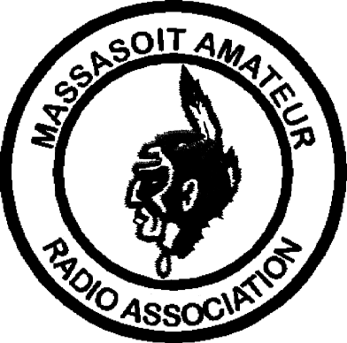MASSASOIT AMATEUR RADIO ASSOCIATION
Monthly Newsletter

Club Officers and Committeemen
President: Bob Pratt, KA1DZA

Vice-President: Bob Mandeville, N1EDM
Treasurer: John Wittey, N1PRK
Secretary: Gil Follett, WA1GDJ
Repeater Trustee: Jay Zappulla, N1FDX
Callsign Trustee: Carl Aveni, N1FYZ

2M Repeater 147.180+ (Tone 67.0) 440 Repeater 444.550+ (Tone 88.5)
WHIT Node 145.090 WA1GDJ-7 (Whitman) DXCluster K1AJ, 145.690; PILGRM Node 145.730
MARA Web page www.qsl.net/w1mv WARC Web page www.qsl.net/wa1npo

Monthly meetings are held the 3rd Tuesday of each month at 7:30PM at the Bridgewater Public Library in Bridgewater Center. Talk-in is on 147.180+

Our Meetings-On-The-Air are held every other Tuesday evening at 8PM on 147.180+ and includes the Westlink News Report with the latest news about happenings in the world of Amateur Radio.

The South Shore Skywarn Net is held every Saturday evening at 8PM local time on 147.180+ and is open to all hams.

From:
Massasoit Amateur Radio Association
PO Box 428
Bridgewater, MA 02324

June, 2000

To:

