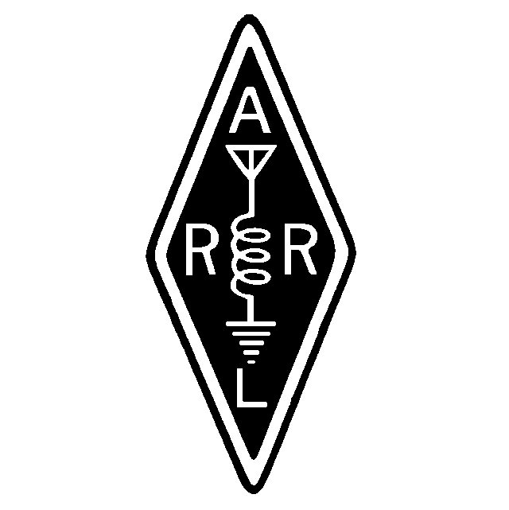
Founded January 6, 1962

July, 2000

Volume XXXIX Issue 7

From the desktop of Bob Pratt
{Editors note} We all know the confusion and insanity that is usually associated with the start of a new job and career. Bob is going through that right now. He will have comments for us next month. For July, let’s all cut him a little slack – I didn’t have the heart to remind him to write something}.

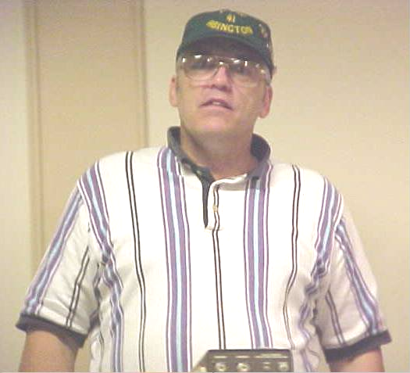
MARA President Bob Pratt, KA1DZA Presiding over his first official meeting
Photo courtesy of Frank Hayes, N1OGP

A MARA Minute
A MARA MINUTE
June, 2000

MEETING OPENED: 2000
President Bob Pratt KA1DZA presiding.

DIRECTORS PRESENT:
KA1DZA, N1EDM, WA1GDJ

TREASURY REPORT: John N1PRK
Gil read the Treasury Report.
Motion: To accept as read. Seconded/Approved

SECRETARY REPORT: Gil WA1GDJ
Gil stated that the Secretary Report was published in the Newsletter/Webpage.
Motion: To accept as published. Seconded/Approved

REPEATER TRUSTEE REPORT: Gil WA1GDJ
Gil stated that all has been well at the VA hospital. We have not been called in during the past month for any radio activities. Our relationship with the VA is growing stronger each day.
- The 440 repeater at the VA is doing well. There have been no flaws in its performance since being installed. Coverage is minimal at that location affording coverage in the Brockton area and south down Rt. 24. This repeater will be at this location until the Motorola repeater is finished and installed at the Water Tank in East Bridgewater.
- The PL board in the Motorola repeater is having a few problems. Hopefully these problems will be overcome in the near future and the radio will be at the Water Tank. In the end, it was determined that the PL board itself was bad and would need replacement. A new board was ordered and will be installed after it arrives.
Motion: To reimburse Gil Follett, WA1GDJ, for $63.68 for a new board. Seconded/Approved
- During the month the 147.18 repeater stopped working. It required work to be done in the shop at Plymouth County Communication. Joe KA1JBE and Paul N1FWD were instrumental in the repair of the repeater. They found a bad board in the power supply system and repaired it. They also installed a 40-watt amplifier and tuned the repeater for maximum smoke. After being placed back at the Tank, everyone found it to perform better than ever. Gil went on to give a little history on the boys from PCC and all the work they have done for the club over the years. Years ago, Paul, N1FWD, donated the repeater to the club at cost and he has maintained it over the years at little or no cost to the club. Joe KA1JBE has spent numerous hours doing repairs and troubleshooting, and just doing his best to keep us on the air. Sometimes it has been necessary to haul it back to the shop for a short while for a transfusion, which is always done quickly and expertly.
Motion: To make Paul N1FWD and Joe KA1JBE honorary members of the club for all the work and effort they have put into the repeaters. Seconded/Approved
- Gil spoke about the antenna party that was held to get the 440 antenna up and the digital antenna up and the link antenna up. Many thanks to all the guys that showed up for this event.
- Gil spoke about the Repeater Trustee group that consists of N1FDX, WA1GDJ, N1FYZ, and N1EDM. He stated that they are looking for someone with technical qualifications to be appointed to the group as repairman/advisor. After speaking with Lou N1UEC, Lou agreed to be a part of the advisory committee and to help in anyway he possibly can. Therefore the trustees appointed Lou N1UEC to the committee.
- Gil spoke on finances for the club briefly. He stated that the present .18 repeater, while in good repair, is old and could fail us at any time. It is time to start thinking about the future. We need to have a steady income into the club. We cannot afford to be broke. Dues cover the basic operation of the club. More money is needed to do other things, such as to take trips etc. Lets come up with some ideas during the next month to get some fund raisers going.
- Gil asked the members for approval for money for Field Day expenses for John N1PRK.
Motion: To authorize the treasurer to allot $125.00 to John for FD expenses. Seconded/Approved

SKYWARN/ARES REPORT:
Gil WA1GDJ
Gil reported that there were 2 Skywarn activation's in this area during the past month. Both were thunderstorms that blew through the area causing little damage. He thanked all the spotters that activated during the callup.

OLD BUSINESS:
Bob N1EDM requested to be reimbursed $61.00 for expenses for the Newsletter for the past 3 months.
Motion: To pay $61.00 to N1EDM. Seconded/Approved
- Gil WA1GDJ submitted bills to be paid for the antenna party: $47.50 to Marino for connector and wire and $60 to Gil for miscellaneous parts for antennas.
Motion: To approve the payment of these bills. Seconded/Approved

NEW BUSINESS:
Carl spoke about the MEMA drill that will be held on the next Monday evening at the Bridgewater EOC. He will need a few operators and it will be a paid event with the proceeds going to the club. The event will start at 1900 at the EOC under the police station.
- Carl spoke about a Hurricane program that will be put on through MEMA. More information will be passed during the NETS.
- Bob spoke more on moneymaking events. We need to have some ideas that the members can participate in for fund raising. Any ideas will be welcomed and considered. Carl spoke up and suggested that everyone realizes that the club is NOT a repeater club and that monies can be used for other events.
- Bill W1ULJ asked how come the 50/50 raffle was stopped. Many members didn't even know that we used to have one at the meeting. This is a split-the-pot raffle. Mark said that the tickets are in the Treasurer kit.
Motion: To restart the 50/50 raffle during the monthly meeting and to continue it all the time. Seconded/Approved
- Bill W1ULJ donated some electronic components and books to be auctioned off. These items brought $20.00 to the treasury.

Meeting closed at 2130.

Respectively Submitted
Gil WA1GDJ, Secretary

How not to fix a Bencher
By Bob, N1EDM
I learned a (financially) painful lesson not so long ago. My Bencher BY-1 paddle wasn’t working so well. A look at the “brass” contacts showed me that they were a bit dirty. Being the fastidious person that I am, I promptly got some very fine 600-grit emery paper and cleaned them. Voila! They worked really well……, for a while.
After a few more cleanings, the paddles got worse instead of better. Something was clearly amiss. An email to Bencher describing the symptoms and my fixes brought the response – those contacts are not brass. They are gold-plated silver! All I had was some very expensive, gold-filled emery cloth.

Bencher told me that contacts cost only $0.61 each plus $6 S&H. That isn’t too bad until you find out that the old contacts cannot be removed, and the new ones cannot be installed with common hand tools.

In real life, the cost for two new pair of contacts, (one pair already mounted to the arms of the paddle), cost a bit under $40 for all the pieces. OK, wipe that smirk off your face. This is just a heads-up so that you don’t make the same mistake that I did!

Field Day Wrap-Up
What’s to tell? Weather was perfect, if a little hot, the bands were in pretty good shape overall, though 15 was a little dry. 20 Phone got the most QSO’s, and 40 CW got the most points. Here is how the scoring broke down for us:

Band CW QSO’s Phone QSO’s
80 80 0
40 193 35
20 1 263
15 34 2
10 23 57

Total 331 357

As for the food, a million thanks to John, N1PRK, for taking on the thankless task of feeding us well. He must have an insurance rider out on those of us who stayed overnight. Sunday Morning’s breakfast was a true heart attack special. We could feel our arteries clog as we ate it, and it was worth every bite!!

Thanks to the entire crew: N1FYZ set up a 20M station and brought his generator. K1DC loaned us his generator even though he was on his boat all weekend. Roy, KB1CYV, was there to help out. Special thanks to those who showed up for setup and tear down.

Don Tanguay, NN1D, was there from the beginning to help set up, and then sat 40M for hours on end to start the CW points rolling in. Great fist.

Sunday morning found everyone a little tired, especially N1FYZ, who had pulled another of his famous “All Nighters”. His score shows it. Nice work, Carl. Winds started to pick up, skies started to darken, and thunderstorms were in the forecast. At about 11:00AM, the “Skywarn Mentality” kicked in and the crew decided that taking down large elements of copper and aluminum with electricity crackling out of the heavens might not be great head-work, so we decided to bag Field Day for another year.

A big vote of thanks goes to Gil. Gil dug up the resource to get the Enterprise Newspaper article published. In addition, he also brought down his complete VHF station, with antennas. All that work for naught, though, because VHF just didn’t seem to hear anything. But Gil got us on to Packet, and that was worth 100 bonus points!

When Jane, the reporter from the Enterprise, came down, she wound up interviewing most of the teardown crew for about an hour. A lot of the takedown was done by Myron, N1XJK. Thanks for all the help, Myron.

If you haven’t been there, head up to the club Web Site www.qsl.net/w1mv and see what Gil did with photos, etc, from Field Day. Also, take a look at the article that Jane wrote about us in the Enterprise. She was very interested in what Hams could do. Carl, Gil, Bob (DZA) and others all chipped in with their anecdotes, and Jane did an exceptional job of taking all those notes, synthesizing it all down, and writing a really well-done article about Ham radio. It’s all on the web site.

Club Auction in August
Dave Darois, WA1UMT, sent an email to Gil regarding some items he is donating to the club for auction. Profits will benefit the club. In Dave’s own words, he wrote:

Hi Gil,
This is the info on the items I have, that I would be willing to donate to the MARA club for a fund raising auction:

1. Realistic AV900 AM/FM Stereo Receiver. Output is 35 Watts per channel. Receiver is capable of decoding TV Audio, Stereo, and SAP. Inputs and outputs are both cable ready, and RCA. It has a digital display, and remote control. It comes with instruction manual, and complete Technical Manual. Original flyer with picture, description, and price included. Note: this unit works, but needs work.

2. Two 5-Watt Analog Cellular Mobile Phones; a Realistic model CT-100 with accessories, and complete Technical Service Manual, and a Nokia model LX series with bag for portability from vehicle to vehicle. Instruction manual included.

Both Cell phones come with proof of ownership. Please let me know if this is enough info.

73's
Dave (WA1UMT)

Can Drive
by Gil, WA1GDJ

Since the discussion (at the June meeting) on making money for the club a few of us have decided to take a little action and get something going. After a little discussion over the FD weekend with a few of the members, Joe W1JOE and myself decided to undertake a can drive, something simple that will only involve members if they have extra cans in their normal life that they would like to donate to the cause. All proceeds will go to the club treasury. Already we have a dozen participants so we are off and running.

Should you collect your cans and plastic bottles (no glass thank you) we will be more than willing to come to you and pick them up. We would also be willing to take any at the club meetings should anyone like to turn them in that way. Whatever works easily for you works for us. Should this be an inconvenience to you we understand that and please don't feel pressured into this. It is only if you wish to contribute those little rascals that tend to pile up in a corner.

Should you have a donation we can be reached at: 781-857-1019
Please leave a message and we will make arrangement to pick them up.

Thanks for any and all efforts.
73 Gil and Joe

[Editor’s note: After Gil wrote the above article, a modification to the idea surfaced. Let’s say that you want to help the club, but you cannot stand to let these cans pile up into a 10-foot mound in your back yard. And, let’s say that you don’t want to drag them to the meeting in your new Mercedes just to give them to Gil.

If you are like that, take them to the reclamation center yourself and put the money aside in an envelope, empty coffee can, whatever! Then, just bring the money in and give it to Gil. We will publish periodic reports on how the can drive is doing.

The Hunger Site
Donate Food for Free to Hungry People in the World. {This article ran several months ago in MARANews, but it’s such a good idea we decided to run it again. Thanks to MaryAnne and Gary for bringing this to our attention, and thanks to Gil for putting a link on the MARA Web Site at www.qsl.net/w1mv.

Just clicking on the link provides food for a hungry person. Every 3.6 seconds someone dies of hunger. 75% of these are children. The Hunger Site. Is operated by GreaterGood.com.

4 Sale
Yaesu FT-50RD with spk.mic, and extra battery for $175.00

Icom IC-Q7A mini HT with spkr mic for $100.00
Contact, Matt N1ZZR
Nextel600@aol.com

Club Hats and Badges

It’s been a very long time since the club has had any patches for sale. Many of the newer members have probably never seen one. Gil Follett, WA1GDJ, is working hard to rectify that problem.

At the July club meeting, Gil will present samples of monogrammed hats and patches for the club. These are quality items, and MARA is probably the only club in the area not currently sporting our own badges.

Gil will give the lowdown, and a ‘fashion show’ at the July meeting, so come and see what he’s got, and listen to a story or two about how he found these sources.

New members will want one, or more. Veteran members will want these new ones and put their original patch in a safe place, as a collectable item.

As a piece of trivia, does the MARA Indian head look familiar to you? It should. If I have the story right (and I usually don’t), according to Bill, W1ULJ, that Indian head was the logo from the old Shawmut bank. Bill had a hand in designing the original patch. Bill, if that isn’t correct, straighten me out at the next meeting. The members would be very interested in the story of how the patch was designed.

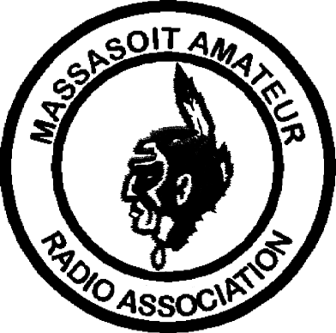MASSASOIT AMATEUR RADIO ASSOCIATION
Monthly Newsletter

Club Officers and Committeemen
President: Bob Pratt, KA1DZA

Vice-President: Bob Mandeville, N1EDM
Treasurer: John Wittey, N1PRK
Secretary: Gil Follett, WA1GDJ
Repeater Trustee: Jay Zappulla, N1FDX
Callsign Trustee: Carl Aveni, N1FYZ

2M Repeater 147.180+ (Tone 67.0) 440 Repeater 444.550+ (Tone 88.5)
WHIT Node 145.090 WA1GDJ-7 (Whitman) DXCluster K1AJ, 145.690; PILGRM Node 145.730
MARA Web page www.qsl.net/w1mv WARC Web page www.qsl.net/wa1npo

Monthly meetings are held the 3rd Tuesday of each month at 7:30PM at the Bridgewater Public Library in Bridgewater Center. Talk-in is on 147.180+

Our Meetings-On-The-Air are held every other Tuesday evening at 8PM on 147.180+ and includes the Westlink News Report with the latest news about happenings in the world of Amateur Radio.

The South Shore Skywarn Net is held every Saturday evening at 8PM local time on 147.180+ and is open to all hams.

From:
Massasoit Amateur Radio Association
PO Box 428
Bridgewater, MA 02324

August, 1999

To:

