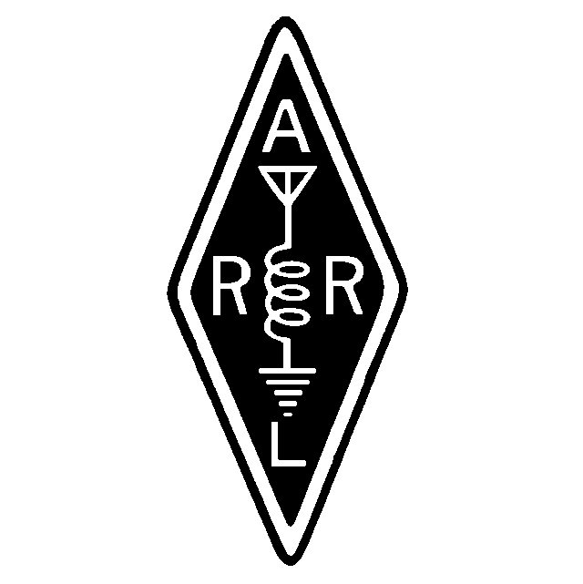
Founded January 6, 1962

January, 2000 Volume XXXVIII Issue 1

From Dave

I was glad to see a good number in attendance last month, even though the meeting came close to a busy holiday period. We had a good business meeting, followed by two interesting videos. Our thanks go to George and Gil for bringing them in.

This month we will be starting off the New Year with a mini-auction at the meeting. Please bring all those radio items for which you no longer have any use, for you are likely to find someone who is willing to give them a good home!

I look forward to seeing you all at the January meeting (18th).

73,
Dave Clemons K1VUT

A Mara Minute
Minutes of the December, 1999 Meeting

MEETING OPENED: 2000
Meeting presided by Dave K1VUT
Directors Present: K1VUT, N1EDM, WA1GDJ, N1ZGT

TREASURY REPORT: Mark N1ZGT
Mark read the Treasury Report.
Motion: To accept the report as read. Seconded/Approved

SECRETARY REPORT: Gil WA1GDJ
Motion: To accept the report as published. Seconded/Approved

REPEATER TRUSTEE REPORT: Jay N1FDX, Gil WA1GDJ
Jay started the discussion by thanking all the people that helped in the chores at the repeater site during 1999. Jay said there are a lot of chores that will be done during 2000 and turned this discussion over to Gil.
- Dave made a motion: To repay Gil for expenses for work at the repeater sites. Seconded/Approved
- Gil thanked everyone that gave their time to help with the work at the repeater site. He also thanked John N1PRK for loaning his video camera for recording the Water Tank operation, and to Tom N1ZZM for editing the tape to VHS format.
- The 440 Standard repeater is being worked on by Joe KA1JBE in his spare time. The repeater has had a hard time adapting to the new controller. The repeater is old and over the years has had many undocumented modifications done to it. Joe and his boss are attempting to figure it out and get it functioning properly. Hopefully, in the next few weeks this will be completed.
- Gil told of the efforts being done at the VA Hospital in Brockton. Antennas are being installed at two building; one at the operations building and the other at Carl’s building. Carl will be having a radio and antenna in his office for communications both Ham-wise as well as Emergency-wise. A small group of club members have formed a group to give the VA emergency communications through Amateur Radio. This group will be standing by New Years Eve at the VA Hospital in case their assistance will be needed.
- Gil spoke about the difficulty we’ve had with the old duplexers over the years, and said that the time has come to replace them. He had hoped that they would hold up longer, but a problem has been found that makes them non-repairable. The repeater is presently being run with loaners from Bill N1DZD. These will have to be returned in short time. Now is the time to purchase them. Gil recommended Wacom Duplexer WP672 6 cavity UHF tuned to frequency with can cables. List price is $1175. Our Ham-discount price is $881.25, or 25%. With shipping it will be $902.28. After a lengthy discussion it was agreed that we buy this 6-cavity duplexer rather than getting a lesser grade 4-cavity model. The intermod problems at the hill are tremendous and we should not cut corners in this department.
Motion: To purchase a new Wacom 6-Cavity Duplexer for $902.28.Seconded/ Approved.
- Gil spoke on the subject of procuring a preamp for the 440 repeater. The one that has been used is out of a junk box. It’s been used for many years and is failing badly. In the last year we have had 3 installed at no cost to the club and the one presently being used is failing. Gil suggested purchasing an Advanced Receiver Research Preamp that should go for approximately $82.
- Gil spoke on about a grounding kit that needed to be installed on the .18 repeater hardline. The kit is a clamp that attaches to the hardline and grounds to the tank at the base of the antenna. This is a ‘must’ to keep lightning strikes from getting to the equipment. We have already been hit several times and lost gear. Our professional climber Marino N1PVP suggested that this be used and he would be able to get one at cost for approximately $25. He will go back up and install it the next time we have to go up.
Motion: To purchase a hardline ground kit. Seconded/Approved.
- Jeff, N1ZZN pointed out that a Motorola Mitrek repeater has been offered to the club for the cost of the crystals. It is a 25 watt unit and is being offered by Lou N1UEC, if we would like to have it. He will get the crystals, install them, tune it to frequency and make sure it is in good running condition. Jeff said that this would be a donation from Lou and that if we decide to get it we might make a donation to his club. After a lengthy discussion it was agreed that this could be a worthwhile endeavor and that we could definitely use it. Gil suggested that the cost of the crystals could be around $80 which would be a normal charge. The members present showed great interest in this purchase. Gil was instructed by the members to look into this further and report back in January with information.

CLUB CALLSIGN TRUSTEE: Carl N1FYZ
Nothing to report

SKYWARN/ARES REPORT: Gil WA1GDJ/ Carl N1FYZ
Carl reported that the NWS Taunton is interested in Wind Velocity and Damage Reporting. They would like to know of anyone having this capability and can report on a regular basis.

OLD BUSINESS:
1. Mark N1ZGT stated that there were several people that were unable to make the Christmas Dinner and that he had their monies to return to them. This could be handled at the end of the meeting if any of those people were here.

NEW BUSINESS:
- Carl told everyone that he would be doing his annual Santa Bulletins on Christmas Eve. The bulletins will be posted at 7:00, 8:00, and 9:00PM on 147.180 repeater.
- Carl also spoke on the Y2K New Years Eve at the VA. The hospital’s director requested Carl’s presence to provide emergency communications to the Boston area VA Hospitals, if needed. Presently, Brockton, West Roxbury, Jamaica Plain, and North Hampton are linked by Amateur Radio on 2 meters and 440 MHz. In effect, Amateur Radio is now a part of their Emergency Communications Network.
- Dave read a letter received from the East Bridgewater YMCA thanking us for our donation for our use of the grounds on Field Day last June.
- Dave read email from Geof Bates, G0FHT, from England (who visited the club during the summer), wishing us a happy New Year.
- Dave said that the January meeting will have an auction. Anyone wishing to participate should bring any gear you wish to get rid of.
- Jeff said he had some CD’s for sale at this meeting. Proceeds were for his school band.
- Dave said that the March meeting would be a discussion by Dennis, N1KXD, on Tubes. Anyone having tubes to be checked could bring them at that meeting.

NEW MEMBER:
Mike Canney, K1MRG, presented his application for membership and spoke of his history in Amateur Radio dating back into the 50’s.
Motion: To accept Mike K1MRG as a full member. Seconded/Approved

MEETING ADJOURNED: 2115
Afterward, Video’s of the Water Tank repair and antenna raising event were shown.

Respectively submitted
Gil WA1GDJ, secretary

Amateur Restructuring is Here:
Three License Classes, One Code Speed
Newington, CT, Dec 30, 1999

Amateur Radio will get a new look in the new millennium. The FCC today issued its long-awaited Report and Order in the 1998 Biennial Regulatory Review of Part 97--more commonly known as "license restructuring." The bottom line is that starting April 15, 2000, there will be three license classes--Technician, General, and Amateur Extra, and a single Morse code requirement--5 WPM.

"We believe that an individual's ability to demonstrate increased Morse code proficiency is not necessarily indicative of that individual's ability to contribute to the advancement of the radio art," the FCC said.

Besides drastically streamlining the Amateur Radio licensing process, the FCC said its actions would "eliminate unnecessary requirements that may discourage or limit individuals from becoming trained operators, technicians, and electronic experts."

Although no new Novice and Advanced licenses will be issued after the effective date of the Report and Order, the FCC does not plan to automatically upgrade any existing license privileges. The ARRL had proposed a one-time across-the-board upgrading of current Novice and Tech Plus licensees to General class, but the FCC declined to adopt the idea. This means that current licensees will retain their current operating privileges, including access to various modes and subbands, and will be able to renew their licenses indefinitely.

Starting April 15, 2000, individuals who qualified for the Technician class license prior to March 21, 1987, will be able to upgrade to General class by providing documentary proof to a Volunteer Examiner Coordinator, paying an application fee, and completing FCC Form 605.

The FCC's decision not to automatically upgrade Novice and Tech Plus licensees means the current Novice/Tech Plus HF subbands will remain and not be "refarmed" to higher class licensees as the ARRL had proposed. The FCC said it did not refarm these subbands because there was "no consensus" within the amateur community as to what to do with them.

As it had proposed earlier, the FCC decided to lump Technician and Tech Plus licensees into a single licensee database, all designated as "Technician" licensees. Those who can document having passed the 5WPM Morse code examination will continue to have the current Tech Plus HF privileges. "If documentation is needed to verify whether a licensee has passed a telegraphy examination, we may request the documentation from that licensee or the VECs," the FCC said.

In addition to reducing the number of license classes from six to three, and eliminating the 20 and 13 WPM code tests, the FCC also will reduce the number of written examination elements from five to three. [It will also] authorize Advanced Class hams to prepare and administer General class examinations, and eliminate Radio Amateur Civil Emergency Service (RACES) station licenses. RACES will remain, however. "After review of the record, we conclude that we should eliminate RACES station licenses because [they] are unnecessary for amateur stations and amateur service licenses to provide emergency communications," the FCC said.

Under the new licensing scheme, there will be four examination elements. Element 1 will be the 5 WPM Morse code exam. Element 2 will be a 35-question written test to obtain a Technician license; Element 3 will be a 35-question written test to obtain a General license, and Element 4 will be a 50-question written test for the Amateur Extra license. The FCC has left it in the hands of the National Conference of VECs Question Pool Committee to determine the specific mix and makeup of written examination questions. Current Amateur Radio study materials remain valid at least until the new rules become effective in April.

The FCC's new licensing plan means someone will be able to become a ham by passing a single 35-question written examination. The plan also simplifies and shortens the upgrade path from the ground floor through Amateur Extra--especially since amateurs will only have to pass one Morse code test.

Elimination of the 13- and 20-WPM Morse requirements also means an end to physician certification waivers for applicants claiming an inability to pass the Morse code examination due to physical handicap.

The effective date provides a window of upgrade opportunity for current Advanced licensees. Between now and April 15, current Advanced holders may take the existing Element 4B, a 40-question test, giving them credit for having passed the current Extra written examination. Likewise, holders of a Certificate of Successful Completion of Examination (CSCE) for Elements 3B or 4B dated on or after April 17, 1999, will be able to qualify for General or Amateur Extra respectively when the new rules go into effect on April 15, 2000.

The FCC disagreed with the League's suggestion that it undertake a restructuring of operating privileges along with licensing restructuring.
"We believe that in light of ongoing discussions concerning implementation of new and more modern communications technologies within the amateur service community, we should accord the amateur service community an opportunity to complete such discussions and possibly reach a consensus regarding implementation of new technologies before we undertake a comprehensive restructuring of the amateur service operating privileges and frequencies," the FCC said in its Report and Order.

In its amendments to Part 97, the FCC's Report and Order refers to a "Club Station Call Sign Administrator," something that does not exist under the current rules and which was not explained in the R&O itself. An FCC spokesperson said the Commission plans to issue a Public Notice soon to explain the program and to solicit qualified entities to serve as call sign administrators for club station applications.

A copy of the entire Report and Order (FCC 99-412) is available at http://www.arrl.org/announce/regulatory/wt98-143ro.pdf or at http://www.fcc.gov/Daily_Releases/Daily_Business/1999/db991230/fcc99412.txt .
Rick Lindquist, N1RL, Senior News Editor, ARRL HQ

Upgrade Exam
By Bob, N1EDM
With restructuring, the amateur radio community can expect a major turnover on April 15. Our VE group intends to run an upgrade session on that day. Details will follow in upcoming newsletters once we sort all of this out.

As you now realize, there will be NO further Novice or Advanced class licenses issued after April 15, 2000, except for license renewals.

If you would like to upgrade to Advanced for the honor of it, or if you know someone who would like to get their Novice before that particular license class goes away, VE sessions are held on the 2nd Tuesday of every month at St. Claire’s church in Braintree. Upcoming dates for his group are February 12, March 11, and April 8. For more information, contact Pi, K1RV. His email is k1rv@arrl.net. Also stay tuned for possible CW classes for those wanting to get their 5WPM code speed requirement.

For Sale
Don Tanguay, NN1D, has a Mirage 215 2M amplifier for sale. Don is asking $100 or best offer. You can reach Don at NN1D@cs.com or you can via twisted pair. Don is in the book in Middleboro.

Matt Connors, also has a collection of items for sale, listed below. See Matt at Corvette9340th@aol.com

Yaesu FT-50RDHP with FTT-12 keypad. The radio comes with dry cell battery pack, heavy duty speaker.mic, rechargable battery, and a wall charger. Asking $ 250.00 for all or best offer.

Radio Shack Multi-band Receiver. Receives short-wave, CB, FM, AM, VHF, TV and aircraft. Boxed and Brand New! Asking $35

D104 Night Eagle Desk microphone prewired for a 5 pin connector. Can be wired for anyother radio. Asking $ 50 or best offer.

Radio Shack 100-channel 30-800MHZ portable scanner. Includes a special stubby antenna from the factory. Asking $100.00 or best offer.

Icom ICQ-7A dual band HT with extended RX (30-1200 MHZ). Comes with spk.mic. Asking $125.00 or best offer.

One pair of Motorola Talkabout FRS radios. Used very little, in excellent condition. Asking $85.

ICOM-707 Info, please?
Don, NN1D, is thinking about getting an ICOM-707. Has anyone used this rig, or do you have any information that you can share with Don? Contact him at NN1D@cs.com, see him on the repeater, or contact him at home. He’s in the book in Middleboro.

Marconi Spark Gap
By Bob, N1EDM
This is an experiment. And a small ego-trip. The photo below is a picture of your dear, beloved editor examining the spark gap transmitter at Marconi Park in Wellfleet.

The unit is a 1/6th scale model of Marconi’s original spark gap transmitter used at the site from 1903 until the advent of Continuous Wave, or CW. The transmitter has a plaque stating the “Old Timers Club” built it. This photo was taken during a rededication ceremony of a bust of Marconi by his last surviving daughter, Princess Elettra Marconi.

Does the transmitter actually work? Well, we’re not sure if it transmits, but it sure does emit some honest-to-gawd sparks. How do you measure the SWR?

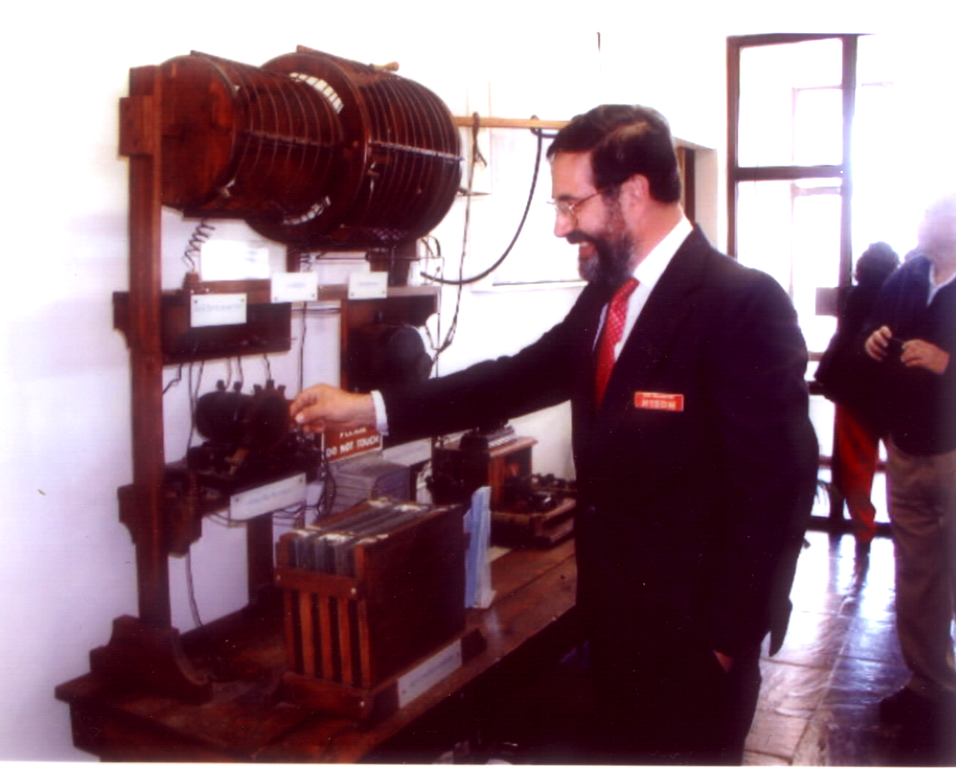
Scale Model Marconi Spark Gap

We are experimenting with photos and graphics in the newsletter from time to time. Those members who do not receive the Microsoft Word version cannot, of course, see these photos.

Our goal is to get everyone on electronic distribution to be able to read a WORD version of MARANews and let us publish a photo or two from time to time. Hint:, you don’t have to have WORD installed on your PC, only a free WORD reader, available from Microsoft.

Sorry about the Quality
The print quality of the December ’99 MARANews was not up to our standards. Unfortunately we had to get the copying done at the last minute at a new copy center. That copy center has done work for us in the past, and done it with better quality. This time, they were just not up to par.

We didn’t catch the poor quality in time, so the newsletter had to go out ‘as-is’. For those of you with the xerox copy, that ‘blotch’ on the rear page was a drawing of Santa sitting in a rocking chair holding a puppy. We hope the graphic in this month’s newsletter will be up to better standards. We’ll know what to watch for, next time.

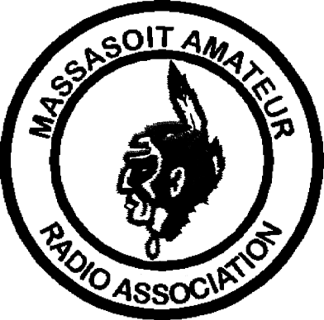MASSASOIT AMATEUR RADIO ASSOCIATION
Monthly Newsletter

Club Officers
President: Dave Clemons, K1VUT

Vice-President: Bob Mandeville, N1EDM
Treasurer: Mark Norris, N1ZGT
Secretary: Gil Follett, WA1GDJ
Repeater Trustee: Jay Zappulla, N1FDX

2M Repeater 147.180+ (Tone 67.0) 440 Repeater 444.550+ (Tone 88.5)
WHIT Node 145.090 WA1GDJ-7 (Whitman)
MARA Web page www.qsl.net/w1mv WARC Web page www.qsl.net/wa1npo

Monthly meetings are held the 3rd Tuesday of each month at 7:30PM at the Bridgewater Public Library in Bridgewater Center. Talk-in is on 147.180+

Our Meetings-On-The-Air are held every other Tuesday evening at 8PM on 147.180+ and includes the Westlink News Report with the latest news about happenings in the world of Amateur Radio.

The South Shore Skywarn Net is held every Saturday evening at 8PM local time on 147.180+ and is open to all hams.

From:
Massasoit Amateur Radio Association
PO Box 428
Bridgewater, MA 02324

January, 2000

To:

