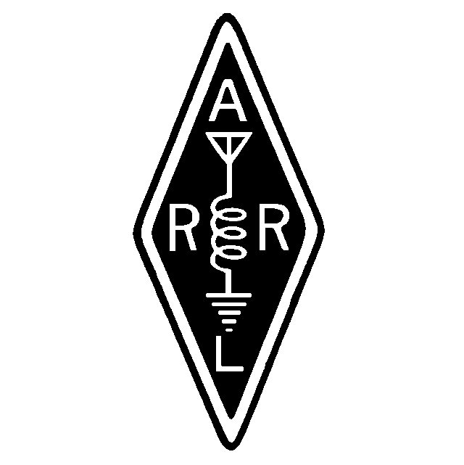
Founded January 6, 1962

April, 2000

Volume XXXVIII Issue 4

From Dave
I was unable to attend last month's meeting, but I heard that it was interesting as Dennis again gave a good tube demonstration. Those of us who have been licensed at least 20 or 30 years probably never thought the day would come when tubes in amateur gear would become almost non-existent. The older rigs that I grew up with always seemed to have a 6146 and a 12AX7 in them. Nowadays if we are operating a rig manufactured in the last 10 years which has a tube in it, it is almost assuredly a high power amplifier. Our equipment certainly has changed in last 30 years, and it will be interesting to see the changes over the next few decades as well.

We are about to enter the prime antenna installation season. This you realize to be true unless you are one of those who subscribes to the theory that antennas have 3db more gain when installed in weather so cold that you get frostbite and the skin on your fingers turns dark purple - just before your fingers start to fall off. If you are one of these people, then you are crazy...just slightly more crazy as I was to be up on a tower a couple of Februarys ago when an unexpected snow shower came through.

That aside, however, we should be experiencing the peak of the present sunspot cycle this year, so now is the time to put together those antenna installation plans. This month we will be voting on the proposed changes to the bylaws. This is your club, so I'd like to encourage you not to miss this meeting unless hampered by something unavoidable.

73, Dave Clemons K1VUT

A MARA Minute
Meeting Minutes March, 2000

MEETING OPENED: 2000
Vice President Bob N1EDM presiding

TREASURY REPORT: Mark N1ZGT
Mark read the Treasury Report
Motion: To accept as read. Seconded/Approved

SECRETARY REPORT: Gil WA1GDJ
Gil stated that the Secretary Report was published in the Newsletter/WebPage
Motion: To accept as published. Seconded/Approved

REPEATER TRUSTEE REPORT: Jay N1FDX Gil WA1GDJ
Jay spoke about the 2-Meter repeater. He said that the repeater is presently running on the loaned 30-watt brick amplifier. Our Motorola Amp has been so much trouble that it has been sent back to Motorola to have an evaluation done at a minimal expense. At the conclusion of their report we will make a decision to have it repaired or trashed.

Gil spoke on the progress of the 440 repeaters. The Standard is in bad need of a good preamp for the receiver. A few months ago the club approved purchase of one preamp but now that we have another repeater we will need one for that also.
Motion: To purchase two Advance Receiver Research preamps for the 440 repeaters. Seconded/Approved.

SKYWARN/ARES REPORT: Carl N1FYZ
The NWS in Taunton will be holding open house on the last weekend in May. It will be a Saturday and Sunday event. There will be booths presenting the many aspects of NWS. Skywarn will be having their own booth and members are asked to help participate with it. Carl suggested that all amateurs should stop by and enjoy the friendship of the crew at NWS Taunton. If anyone has not been there before they will find the new NWS very interesting.

NEW BUSINESS:
- Carl informed the group that Ron N1PXX is in the Good Sam Hospital and will be undergoing examinations. The Secretary was instructed to send him a get well card from the club.
- Carl said that he was at a MEMA meeting last week, and that they spoke of replacing the BEACON radio system that connects the EOC stations in Massachusetts.
- The official final report on the Pilgrim exercise is out and the entire system was handled excellently and that the communications department was singled out for the outstanding job that it did.
- Gil said that Gene N1EH and a few others are anticipating doing a demonstration on APRS in the months to come. He queried the members to see if anyone would be interested. There was a good showing of interested people. He said that he would get back with information at a later date. Gil also stated that there would be an APRS demo at the Open House at NWS Taunton.
- Carl said that the NWS is starting a River Watch system using the SKYWARN observers. There will be more information coming up in the near future.
- Jeff said that the Framingham Flea would be the following weekend.
- Carl asked the members to approve a $10 increase in the price of a dual band base antenna that we had approved and Jeff would be picking up next weekend Motion: To approve the purchase of the antenna at $40. Seconded/Approved.
- Don K1DC reported that he would be VP2V/K1DC for the first week in the British Virgin Island. He will be operating on the HF bands and hopes some of the locals will be able to make contact with him.
- Bob spoke on the VE session on April 15. He is looking for help on this event. It will be held at the East Bridgewater Public Library. There is plenty of parking. Doors will be open at 0900 for walk-in examinations. The 605 forms can be downloaded from the web and will be accepted at the VE sessions.
- Bill W1ULJ donated a 1976 Amateur Handbook to be auctioned off.
- Bob said that he has been experimenting with the newsletter by formatting with one column instead of the two.
- Mark N1ZGT took over the rest of the meeting explaining the process they used for reviewing the Bylaws. He then went over all the changes that will be purposed and there was discussion on all these points. At the conclusion of the discussion the committee was sent back to make a couple small changes so that the New Bylaws will be able to be voted on at the April meeting.

NEW MEMBERS:
David Newman WB1EVP from Kingston was present and applied for membership in MARA. After David spoke to the members on his activities he was voted a Full Member.
Motion: To accept David Newman as Full Member. Seconded/Approved

MEETING CLOSED: 2200

ADA Tour De Cure

The American Diabetes Association is hosting their annual ADA Tour De Cure from the Marshfield Fairgrounds on June 11. This event raises funds for Diabetes research. Many if not all of us know at least one person stricken with this disease. To those who have done this before, the event is a lot of fun, and you walk away with a feeling of having done something important, (as well as a T-shirt and a free lunch!). Here is an event where Ham Radio is a major help to these people.

If enough people come out, I would like to see an HF station set up and maybe even a packet station. I like these events to be fun for everyone and to show the public a little bit about the hobby. This is a great way to do it! I have also ridden this tour with the 2m rig on the bike so that may trigger some interest as well.

73's De N2JWW, Mike Halifax

Boxboro is coming
Yes, it’s that “Every-Other-Year” event, the NE Div Convention at Boxboro. It is scheduled for August 26-27. If you haven’t been there, you have to go! The flea market, already big, will be 30% larger this year. The W1 QSL Bureau will be there. All the major national distributors will also be in attendance, and you can count on a lot of “Show Specials”. Lots of other people go for the seminars and/or the YCCC meeting. Don’t forget a copy of your QSL card for the ever-popular QSL Card Contest. You can find out more about it by popping in to www.boxboro.org now and again as the site is updated.

The Prizes give-away will be expanded, with over 85 prizes given away. As usual, you must be in attendance for the hourly prizes, but you will be notified if you have won one of the grand prizes!

If you would like to see the New England Division web site, it is sponsored by BARC. The site is at www.barc.org/barc/nediv.

FCC Shifts License Color:
The ARRL has learned that the FCC's Gettysburg office has begun issuing new Amateur Radio license documents on blue paper instead of the beige stock that hams have become accustomed to for many years. Wireless Telecommunications Bureau personnel say the new licenses are printed on whatever color "safety paper" stock they have available. "Our policy/procedure is to print all licenses on safety paper, so they can be easily identified as our official documents, but we don't have a requirement as to the color," an FCC spokesperson told the ARRL. "When the last shipment was received they were blue." The change apparently has nothing to do with the recently announced FCC license restructuring.

Regarding some confusion about the new Form 605, this is the only form that the FCC will now accept for upgrades, etc. But hold on, there are now two 605;s to deal with!

The first is the standard form 605 that you can download everywhere, including www.fcc.gov/forms. This form 605 can be sent directly to the FCC by the Amateur for such things as address changes, license renewals, etc.

If you are attending a VE session, save yourself some writers cramp and complete the NCVEC Quick-Form 605 – it’s a lot faster and easier. But this form may only be used at a VE session. This form goes to the VEC (not the FCC) and the VEC electronically transmitts the data to the FCC. ‘nuff said.

By-Laws Updates
By Mark Norris,
The By-Laws committee met at Treasurer Mark Norris’s house (N1ZGT) to consider March’s changes to the bylaws, as printed in the March MARANews. Below are a summation of these changes.

- Changed typo on dues date from April 30th to March 31st.
- Added Life membership; "A Lifetime membership may be purchased by a full member for an amount of 15 times the current full membership dues."
- Made family membership a straight 30 as has been the practice.
- Reduced Associate dues from $25 to $10.

Harry Ketler, W1DGD, has agreed to be the spokesman at the meeting to explain and coordinate the latest revisions to the Massasoit ARA Bylaws.

IMD
On April 29, over 60 International Marconi Day Special Event stations will be participating in world-wide to commemorate milestones in the development of worldwide wireless communications.

The Marconi Radio Club, W1AA/IMD of Massachusetts will represent the Marconi Transatlantic Station where Marconi completed his first spark gap radio transmission between the United States and Europe on January 18, 1903. The Marconi Radio Club will have several stations on the bands for the event. You can see the local information at the Marconi Radio Club W1AA web site at http://personal.tmlp.com/k1vv/w1aa/. Additional International links include http://www.users.globalnet.co.uk/~straff/

Web sites for some participating clubs include:
Cornish Amateur Radio Club http://www.users.globalnet.co.uk/~straff/
Newfoundland Radio Club http://webhost.avint.net/sonra/marc100.htm
Glace Bay Nova Scotia http://www.users.globalnet.co.uk/~straff/glacebay.htm
Twin Lights, Highlands, N.J. http://www.users.globalnet.co.uk/~straff/twinlights.htm
Rochester, Kent http://www.users.globalnet.co.uk/~straff/rocheste.htm
Dorchester Wireless Station http://www.users.globalnet.co.uk/~straff/dorchester.htm
Wall, N.J. http://www.users.globalnet.co.uk/~straff/wall.htm
Coltano, Pisa http://www.users.globalnet.co.uk/~straff/coltano,.htm

Another station taking part will include the Sydney Olympics special event call sign, which will make its debut on IMD as AX2000/IMD. The call sign will be "pronounced" as "A-X-two thousand."

- Bob "Whitey" Doherty K1VV, President - Marconi Radio Club W1AA

For Sale
From Stan Rogers, W1LJH – Kingston. (781) 585-2468
- Kenwood TR-2600 HT. 2.5 watts output. ST2 Base stand and charger, manual. $100.
- Yaesu FT207R, 2.5W. NC-1A Charger for HT or ordinary Battery. NC9A charger, (110VAC) plugs into HT. Handi-Tek 11-16VDC PS for use in place of battery. Debco Mobile Rapid Charger (cigarette-jack plug). Manual. $100
- Mamiya-Secor 1000 Camera w/ 55mm F1.8 and 135mm f1.28 lens. 55mm sky filter. Tiffer closeup 1-24. Bell & Howell Model 10 Flash. Secor Guide-book. Case. $100.
New “Q” Codes
e-mail from VA3MM, K4HB, N9AG
{with thanks to the EUPAR Newsletter for March, 2000} Some Q signals have never made it to the ARRL's official list. Yet you may agree after reviewing those listed here, that at least a few of these would be useful. As with regular Q signals, each can be a statement or a question, depending on whether a question mark follows it.

QLF: "I'm sending with my left foot"
" Are you sending with your left foot?"
QRC: "Warning, rag chewer on frequency."
"Are you a rag chewer?"
QOK: "Your last transmission was okie dokie"
"Was my last transmission okie dokie?"
QFH: "This frequency is mine. Go elsewhere.
"Is this frequency hogged?"
QBS: "Its getting deep in here."
"Did I tell you about the onethat got away?"
QZZ: "I fell asleep on an open mike."
"Is that just 60 hertz hum, or are you snoring?
QBA: "My antenna is big."
"How big is your antenna?"
QHI: "I'm jumping in quick to say hi, then going QRT".
"Are you leaving after only one transmission?"
QBO: "Don't sit next to that guy in the meeting."
"Buddy can you spare some soap?"
QCQ: "Calling CQ in Q signals."
"Is there any end to this madness?"
QCW: "I'm going to whistle Morse on FM (or SSB)."
"Why are you whistling Morse Code?"
QET: "Phone home".
"Has anyone called me from another planet?"
QGE: "I bring good things to the party."
"What good things do you bring to the party?"
QLT: Gimme your last two.
Are you a lid? What kind of call sign is that?
QLZ I do not work List Lizards
Are you a List Lizards?
QWE: I am a Welfare Extra - PSE QRS
Can you copy Morse code?

[Editors note: Well, this is April, isn’t it?]

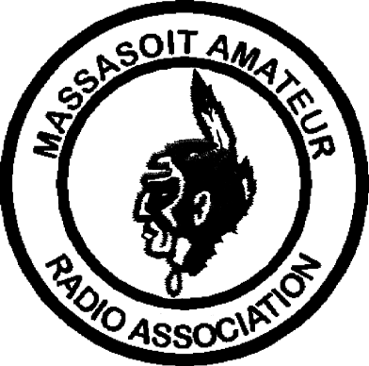MASSASOIT AMATEUR RADIO ASSOCIATION
Monthly Newsletter

Club Officers
President: Dave Clemons, K1VUT

Vice-President: Bob Mandeville, N1EDM
Treasurer: Mark Norris, N1ZGT
Secretary: Gil Follett, WA1GDJ
Repeater Trustee: Jay Zappulla, N1FDX

2M Repeater 147.180+ (Tone 67.0) 440 Repeater 444.550+ (Tone 88.5)
WHIT Node 145.090 WA1GDJ-7 (Whitman)
MARA Web page www.qsl.net/w1mv WARC Web page www.qsl.net/wa1npo

Monthly meetings are held the 3rd Tuesday of each month at 7:30PM at the Bridgewater Public Library in Bridgewater Center. Talk-in is on 147.180+

Our Meetings-On-The-Air are held every other Tuesday evening at 8PM on 147.180+ and includes the Westlink News Report with the latest news about happenings in the world of Amateur Radio.

The South Shore Skywarn Net is held every Saturday evening at 8PM local time on 147.180+ and is open to all hams.

From:
Massasoit Amateur Radio Association
PO Box 428
Bridgewater, MA 02324

April, 2000

To:

